
DESIGN AND IMPLEMENTATION OF A WEB-BASED GEOSPATIAL INFORMATION SYSTEM FOR MAPPING AND MANAGING COMMUNITY WATER RESOURCES, ILORIN METROPOLIS
BY:
USMAN ABDULLAHI BABATUNDE (21/52HL147)

DEPARTMENT OF INFORMATION TECHNOLOGY
FACULTY OF COMMUNICATION AND INFORMATION SCIENCES,
UNIVERSITY OF ILORIN.

SUPERVISOR: MR ALIYU N. ISHOLA

Certification
This is to certify that this project work was carried out by USMAN ABDULLAHI BABATUNDE with matriculation number 21/52HL147 in the department of Information and Communication Science, University of Ilorin, Ilorin Nigeria.

_______________________ ___________________
Mr Aliyu N. Ishola Signature and Date
Supervisor

______________________ ___________________
Dr. Oluyinka Titilope Afolayan Signature and Date
Head of Department

TABLES OF CONTENTS

TABLES OF CONTENTS II
CHAPTER ONE 1
1.1 Background to the Study 1
1.2 Statement of Problem 2
1.3 Objectives of the Study 3
1.4 Scope of the Study 4
1.5 Limitations of the Study 4
1.6 Significance of the Study 5
1.7 Operational Definition of Terms 6
1.8 Organization of the Study 7
CHAPTER TWO 8
2.1 Introduction 8
2.2 Conceptual Framework 8
2.2.1 The Evolution from Desktop GIS to Web-GIS 8
2.2.2 Smart Water Management (SWM) and the Data Deficit 9
2.2.3 Crowdsourcing: The "Human Sensor" Model 9
2.3 Theoritical Framework 10
2.3.1 Participatory GIS (PGIS) Theory 10
2.3.2 Technology Acceptance Model (TAM) 11
2.4 Empirical Review 12
2.4.1 Global Perspectives on Web-GIS 12
2.4.2 Regional Perspectives (Sub-Saharan Africa) 12
2.4.3 GIS Applications in the Nigerian Context 13
2.4.4 Technical Review: MERN Stack and Data Validity 13
2.5 Summary of Literature and Identification of Gaps 15
2.5.1 Summary 15
2.5.2 Identification of Gaps 15
2.6 Conclusion 16
CHAPTER THREE 17
3.1 Introduction 17
3.2 Research Methodology 17
3.3 System Analysis 19
3.3.1 Analysis of the Existing System 19
3.3.2 Weaknesses of the Existing System 19
3.3.3 Feasibility Study 20
3.4 System Design 20
3.4.1 System Architecture 20
3.4.2 Use Case Design 21
3.4.3 Data Flow Design (DFD) 22
3.4.4 Database Design 23
3.4.5 Activity Diagram Design 24
3.4.6 Sequence Diagram Design 24
3.5 System Requirements 25
3.5.1 Hardware Requirements (Development & Client) 25
3.5.2 Software Requirements 25
3.6 Conclusion 26
REFERENCES 27

CHAPTER ONE
INTRODUCTION

1.1 Background to the Study
Water is critical for human survival and is an essential component for sustainable urban development. The management of water infrastructure—including boreholes, public taps, and wells—directly determines the health and economic stability of a population. However, as urbanization accelerates daily in the Ilorin Metropolis, traditional methods of managing these resources have become increasingly inefficient. Authorities predominantly rely on manual records and physical inspections to track water points, leading to significant gaps in information and service delivery.
State agencies, such as the Kwara State Water Corporation, typically manage these utilities using paper-based filing systems. Retrieving real-time information from these physical files is difficult, and sharing data between departments is often cumbersome. This lack of digital data creates a disconnect between the infrastructure's actual status and the records held by the government. Consequently, broken infrastructure in remote areas often remains unrepaired for months due to a lack of visibility.
Information and Communication Technology (ICT) has transformed utility management in the 21st century. Geospatial Information Systems (GIS) have emerged as powerful tools to map and monitor physical assets, allowing for data visualization that identifies patterns—such as clusters of broken boreholes or areas with zero water access—with ease. While developed nations have adopted Smart Water Management (SWM) using automated sensors to monitor pipe pressure and quality, Space4Water (2023) notes that such sensors are often too expensive for widespread use in developing regions. Instead, "Citizen Science" or crowdsourcing serves as a cost-effective alternative, where citizens act as "human sensors" using their smartphones to report faults.
The need for such a system is critical in Nigeria. Olorunfemi et al. (2025) conducted a geospatial assessment of household water conditions and found that a significant portion of the population relies on unimproved water sources. Their study highlighted that Non-Governmental Organizations (NGOs) often struggle to pinpoint locations for intervention due to a lack of precise data. Although Adewuyi et al. (2025) demonstrated the feasibility of a web-based GIS for Ilorin by mapping the pipeline network, their work did not account for decentralized water points like community boreholes, nor did it include a mechanism for public reporting. This project builds upon these existing works by combining geospatial tracking with a crowdsourcing methodology to create a holistic tool for managing Ilorin’s water resources.

1.2 Statement of Problem
Current water management in Kwara State relies predominantly on manual methods, where authorities use physical files and paper records to track infrastructure. This analog approach has created a significant "information gap" that fails the Ilorin metropolis in three critical ways.
First is the issue of static and decaying data. A paper record shows where a borehole was installed years ago, but it fails to reflect its current functional status. If a pump handle breaks today, the paper record remains unchanged. This lack of real-time updates leads to situations where government records show a community has water coverage, while in reality, the residents have been without access for months due to unrepaired faults.
Second is the lack of data access for non-state actors. Non-Governmental Organizations (NGOs) and private philanthropists frequently seek to intervene in water crises but lack verified data on where the needs are most acute. Currently, there is no public database they can query to find communities with broken boreholes. Because this data is hoarded in government files or does not exist at all, NGOs struggle to direct funds effectively, often leading to skewed aid distribution where some areas are over-served while others remain neglected.
Third is the absence of a feedback loop. Residents—the primary users of these resources—are disconnected from the management process. To report a broken pipe, a resident often has to physically visit a ward office, a process that is time-consuming and discouraging. This disconnect means that faults often persist for weeks before they are officially noticed. The lack of a crowdsourcing mechanism prevents the state from leveraging the community as "human sensors" for rapid fault detection.

1.3 Objectives of the Study
The primary aim of this project is to design and develop a web-based Geospatial Information System (GIS) for the Ilorin Metropolis. This system serves to bridge the information gap in water infrastructure management by providing a centralized, interactive platform for mapping, monitoring, and reporting the status of community water resources.
To achieve this aim, the specific objectives are to:
- Analyze the current manual methods of tracking water infrastructure to identify key inefficiencies in the Ilorin metropolis.
- Design a robust geospatial database schema using MongoDB to store location data (coordinates), resource attributes, and media.
- Develop the backend API using Node.js to handle geospatial queries and user authentication.
- Implement a user-friendly frontend interface using Next.js and Leaflet.js for real-time map visualization.
- Create a crowd-sourcing module that allows authenticated users to capture and submit GPS coordinates of new or broken water points.
- Design an administrative dashboard to verify user submissions and update the official status of water resources.
- Evaluate the system using real-world coordinate data to ensure high location accuracy and fast rendering speeds.

1.4 Scope of the Study
The scope of this project is focused on software development and geospatial analysis. Geographically, the study is restricted to the Ilorin Metropolis, the capital of Kwara State. This location was selected due to its rapid urbanization and the heavy reliance of its expanding population on decentralized water sources (boreholes and wells) rather than the municipal grid.
Technically, the system tracks point data (wells, boreholes, and public taps) and records their functional status (Functional, Faulty, or Under Repair). The application is designed to operate on standard web browsers. It is important to note that this project does not involve the physical repair of pipes, nor does it involve the development of hardware sensors or IoT devices.

1.5 Limitations of the Study
Two main factors constitute the limitations of this research:
- Financial Constraints: Professional mapping APIs, such as the Google Maps API, charge significant fees for high-volume usage. To ensure the project remains sustainable and cost-effective for an academic study, OpenStreetMap and Leaflet.js are used as open-source alternatives.
- Time Constraints: Due to the limited duration of the academic semester, a comprehensive mapping of every single water point in the entire Ilorin Metropolis is not feasible. Consequently, the study utilizes a sample dataset from a specific zone to demonstrate the system's functionality and proof of concept.

1.6 Significance of the Study
This study provides distinct benefits to four key stakeholder groups:
The Community: Residents gain a reliable, accessible tool to locate functioning water sources during periods of scarcity. Furthermore, the crowdsourcing feature gives them a direct voice to report infrastructure failures, reducing the time between fault occurrence and repair.
Government Agencies: The Kwara State Water Corporation gains a digital "Asset Register." This data allows for data-driven maintenance scheduling, helping agencies identify high-risk areas based on the frequency of fault reports.
Non-Governmental Organizations (NGOs): Development partners involved in water aid often lack verified data. This system provides a transparent map of underserved areas, ensuring that funds and interventions are directed to the communities that need them most.
Researchers: This project contributes to the academic body of knowledge by demonstrating the practical application of the MERN stack in environmental management. Future students can build upon this data structure for advanced analytics or machine learning predictions.

1.7 Operational Definition of Terms
To ensure clarity and consistency throughout this research, the following terms are defined as they are used in the context of this study:
Geospatial Information System (GIS): A computer-based system capable of assembling, storing, manipulating, and displaying geographically referenced information. In this project, it specifically refers to the web application that displays the digital map of water points in Ilorin.
Crowdsourcing: The practice of obtaining information from a large, open group of people via the internet. In this study, it refers to the "Citizen Science" model where residents of Ilorin use their mobile devices to submit reports about the functional status of water infrastructure.
MERN Stack: A collection of JavaScript-based technologies used to develop the software. It stands for MongoDB (database), Express.js (backend framework), React/Next.js (frontend interface), and Node.js (runtime environment).
Leaflet.js: An open-source JavaScript library used to build web mapping applications. It is the specific tool used in this project to render the interactive map tiles on the user's browser.
Geocoding: The computational process of converting a physical location description (like an address or a pin drop) into geographic coordinates (Latitude and Longitude) for storage in the database.
Water Infrastructure: The physical assets required to access community water. For the purpose of this study, this is strictly limited to point sources such as hand-dug wells, boreholes, and public standpipes, excluding the reticulation (pipeline) system.
Smart Water Management (SWM): The application of digital technology and data analytics to the management of water resources. This project is a practical implementation of SWM using web technologies.
Web-GIS: A form of GIS that is accessible via a web browser (like Chrome or Safari) without requiring the installation of specialized desktop software.

1.8 Organization of the Study
The report is organized into five distinct chapters, each focusing on a specific aspect of the project:
Chapter One introduces the research. It covers the background to the study, statement of the problem, aim and objectives, significance, scope, and limitations.
Chapter Two reviews related literature. It analyzes existing works on GIS, water management, and crowdsourcing technologies to identify research gaps.
Chapter Three details the methodology. It explains the system analysis, design, and the MERN stack architecture used for development.
Chapter Four presents the System Implementation, Testing and Evaluation. It details the results, interface designs, and testing procedures used to validate the system.
Chapter Five summarizes the project. It provides the conclusion and recommendations for future research.

CHAPTER TWO
LITERATURE REVIEW

2.1 Introduction
The review of relevant literature serves as the intellectual foundation for any research undertaking. It provides the necessary context to situate the current study within the existing body of knowledge, identifying both the advancements made by previous scholars and the critical gaps that remain. This chapter offers a comprehensive and critical analysis of the literature relevant to the Design and Implementation of a Web based Geospatial Information System (GIS) for Mapping and Managing Community Water Resources.

2.2 Conceptual Framework

2.2.1 The Evolution from Desktop GIS to Web-GIS
Geospatial Information System (GIS) has historically been defined as a computer-based tool for mapping and analysing things that exist and happen on earth. However, in the last decade, the concept has undergone a radical transformation from "Desktop GIS" to "Web-GIS."
Traditional Desktop GIS (e.g., ArcGIS, QGIS) required heavy installation, significant processing power, and specialised expertise. This created a bottleneck where spatial data was accessible only to experts in centralised offices. Conversely, Web-GIS utilises the internet to deliver geospatial information to any user with a standard web browser. Lins et al. (2023) argue that this democratisation is the single most important factor in modern utility management. For a water corporation, this means that data is no longer locked in a physical file but is accessible to field engineers and the public via smartphones. This shift from a "System of Record" to a "System of Engagement" is the conceptual basis for this project.

2.2.2 Smart Water Management (SWM) and the Data Deficit
Smart Water Management (SWM) refers to the utilisation of Information and Communication Technology (ICT) to provide real-time automated data on water distribution. While developed nations have moved towards IoT (Internet of Things) sensors to measure pressure and flow, developing nations like Nigeria face a critical "Data Deficit."
In the specific context of Ilorin, the reliance on manual record-keeping has led to significant inefficiencies. Olorunfemi et al. (2025) note that a substantial portion of the population relies on unimproved water sources, yet there is no central digital registry to track the functionality of these sources. Adewuyi et al. (2025) further highlight that while pipeline networks have been mapped, decentralised assets like boreholes remain largely invisible to state planners. This project conceptually addresses this deficit by proposing a digital, map-based inventory that acts as the "single source of truth," replacing disparate paper records with a unified cloud-based database.

2.2.3 Crowdsourcing: The "Human Sensor" Model
Crowdsourcing, often termed "Citizen Science" in environmental studies, is the practice of obtaining information from a large, open group of people. In the context of hydrology, this is described as the "Human Sensor" model.
Since installing electronic sensors on every community borehole in the Ilorin Metropolis is financially prohibitive, community members themselves become the sensors. When a user reports a fault via the web application, they perform the function of a digital sensor but at zero infrastructure cost. Space4Water (2023) emphasises that for this conceptual model to succeed in developing nations, the reporting mechanism must be frictionless—utilising simple web interfaces rather than complex, data-heavy applications. This model transforms the resident from a passive consumer of water services into an active stakeholder in infrastructure maintenance.

2.3 Theoritical Framework
To ensure academic rigour and provide a robust foundation for the system design, this research is anchored on two distinct theories: the Participatory GIS (PGIS) Theory, which guides the social aspect of community engagement, and the Technology Acceptance Model (TAM), which guides the technical design of the user interface.

2.3.1 Participatory GIS (PGIS) Theory
Participatory GIS (PGIS) emerged in the late 1990s as a critique of the "expert-driven" nature of traditional cartography. Verplanke et al. (2016) define PGIS as the integration of local knowledge and stakeholder perspectives into the GIS process. The theory posits that a map is not just a representation of geography but a representation of power. When the government makes the map, they control the narrative. PGIS theory argues that empowering citizens to add data to the map (e.g., marking a dry well) shifts the power dynamic, forcing authorities to acknowledge neglected areas.
Operationalisation of PGIS in this Study: In the context of this project, PGIS is not merely a theoretical concept but a design principle. The system is architected to give residents "write access" to the official water map. Unlike traditional systems where data flow is one-way (Government to Citizen), the Crowdsourcing Module implements PGIS by validating community submissions as legitimate data points. This ensures that the resulting map reflects the ground reality of the Ilorin Metropolis rather than outdated official records.

2.3.2 Technology Acceptance Model (TAM)
Since this project involves developing a software application for public use, it is critical to consider the factors that influence user adoption. The Technology Acceptance Model (TAM), originally proposed by Davis in 1989, remains the gold standard for software adoption studies. TAM suggests that two primary factors determine whether a user will adopt a new system:
- Perceived Usefulness (PU): The degree to which a person believes that using a particular system would enhance their job performance.
- Perceived Ease of Use (PEOU): The degree to which a person believes that using a particular system would be free of effort.
Operationalisation of TAM in System Design: This study directly applies TAM to the technical implementation of the MERN stack.
- Addressing Perceived Usefulness: The system is designed to provide immediate visual feedback. When a user submits a report, the marker on the map changes colour (e.g., from Green to Red). This visual confirmation reinforces the utility of the application to the user.
- Addressing Perceived Ease of Use: Recognising that many residents may not be tech-savvy, the frontend (developed in Next.js) prioritises a "mobile-first" design. The fault reporting form is streamlined to require minimal inputs (Location, Photo, Description), reducing the cognitive load on the user. By minimising the friction of reporting, the system maximises the likelihood of adoption in line with TAM principles.

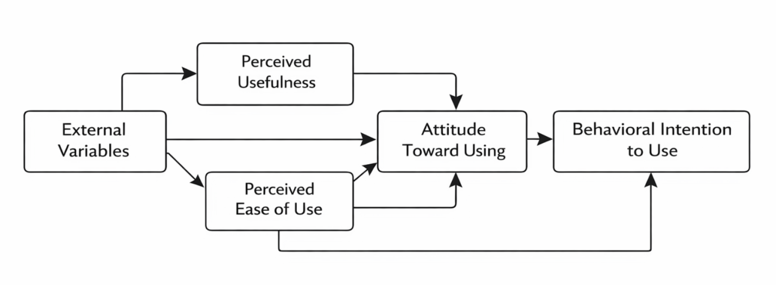
Figure 2.1: Technology Acceptance Model (Source: Davis, 1989).

2.4 Empirical Review

2.4.1 Global Perspectives on Web-GIS
Globally, the integration of GIS in water management is well-documented. In Brazil, Lins et al. (2023) developed a Web-GIS for the Paranapanema river basin. Their study demonstrated that visualising water quality data on a shared web platform significantly improved decision-making between disparate government agencies. However, their system was designed for "high-level" decision-makers and lacked a public-facing interface for citizens to report issues, a feature this current project incorporates to ensure inclusivity.

2.4.2 Regional Perspectives (Sub-Saharan Africa)
In the African context, Cinderby et al. (2011) conducted a seminal study on PGIS in Tanzania. They used mapping to help farmers manage water resources during droughts. The study proved that rural communities, even those with low literacy, could effectively engage with spatial data if the interface was simple. More recently, in Ghana, researchers have used mobile data collection to track borehole functionality. However, many of these projects rely on "Data Collectors" (hired staff) rather than true crowdsourcing (public participation), which limits scalability due to the high cost of hiring staff.

2.4.3 GIS Applications in the Nigerian Context
In Nigeria, Olorunfemi et al. (2025) utilised geospatial techniques to assess Water, Sanitation, and Hygiene (WASH) conditions. Their work confirmed that disease outbreaks in Nigeria are spatially clustered around areas with poor water infrastructure. While this study provided excellent analysis, it was a static research output, not a dynamic management tool. It highlighted the problem but did not engineer the software to solve it.
Closer to this study's location, Adewuyi et al. (2025) worked on "Geocoding and implementation of a web-based water distribution GIS for Ilorin". Their work is the closest benchmark to this project. They successfully mapped the pipeline network of Ilorin. However, a critical review of their work reveals a limitation: it focused almost exclusively on the reticulation system (pipes). It largely ignored point sources (wells/boreholes), which serve the majority of the peri-urban population in Ilorin who are off the grid. Furthermore, their system did not utilise the MERN stack, relying instead on PHP/SQL architectures which are less flexible for modern real-time spatial data.

2.4.4 Technical Review: MERN Stack and Data Validity
Conceptually, the choice of technology dictates the scalability of the system. This project utilises the MERN stack (MongoDB, Express.js, React, Node.js).
Data Validity: A major concern in crowdsourcing is the accuracy of user-submitted data. This system addresses this by utilising the Geolocation API inherent in modern browsers, which provides GPS coordinates with an accuracy of approximately 10-20 metres in open areas. To further validate data, the system requires photographic evidence of the fault, allowing administrators to visually verify reports before updating the official map.
Performance: Shetty and Dash (2020) conducted a comparative review of web frameworks, concluding that the React.js (Frontend) and Node.js (Backend) architecture handles concurrent requests better than traditional architectures. For a crowdsourcing app where hundreds of users might report faults simultaneously during a crisis, this non-blocking I/O capability of Node.js is superior.
Table 2.1: Summary of Related Works
Author(s) & Year | Focus Area | Methodology | Key Findings | Limitations/Gap
Lins et al. (2023) | Water Quality Monitoring (Brazil) | Web-GIS | Visualising data improved agency collaboration. | Lacked public reporting; Top-down approach only.
Olorunfemi et al. (2025) | WASH Conditions (Nigeria) | Geospatial Assessment | Disease outbreaks are linked to poor water infrastructure. | Static study; No software tool developed for management.
Adewuyi et al. (2025) | Water Distribution (Ilorin) | Web-GIS (PHP/MySQL) | Mapped the Ilorin pipeline network successfully. | Focused on pipelines, ignored boreholes/wells.
Space4Water (2023) | Citizen Science (Global) | Review | Crowdsourcing is cost-effective for developing nations. | Theoretical review; No specific implementation for Ilorin.

2.5 Summary of Literature and Identification of Gaps

2.5.1 Summary
The literature establishes that water scarcity is an information problem as much as a resource problem. Global studies (Lins et al., 2023) and local studies (Adewuyi et al., 2025) agree that GIS is the solution. The Theoretical Framework (PGIS and TAM) supports the move towards user-centric, participatory systems.

2.5.2 Identification of Gaps
Despite the extensive work done, distinct gaps remain that this project fills:
- The "Point-Source" Gap: Existing Ilorin studies (Adewuyi et al., 2025) focus on pipelines. There is a lack of digital management systems specifically for decentralised community boreholes and wells.
- The "Feedback" Gap: Most systems are "Read-Only" for the public. There is a scarcity of applications that allow the public to "Write" data (report faults) back to the authorities in the Kwara State context.
- The Technical Gap: There is a lack of academic literature applying the modern MERN stack with Leaflet.js for environmental management in Nigeria. Most local solutions still use older PHP/MySQL architectures, which lack the scalability of NoSQL (MongoDB) geospatial indexing.

2.6 Conclusion
This chapter has critically reviewed the landscape of GIS, Crowdsourcing, and Water Management. It has identified that while the problem of water management is well-known, the solution of a participatory, crowdsourced, web-based inventory remains an uncharted territory in the Ilorin Metropolis. This project is positioned to bridge this gap.

CHAPTER THREE
METHODOLOGY AND SYSTEM ANALYSIS

3.1 Introduction
This chapter elaborates on the research methodology and the technical framework employed in the design and implementation of the Geospatial Information System (GIS) for Mapping and Managing Community Water Resources. It provides a detailed exposition of the software development lifecycle, a critical analysis of the existing manual system, and a comprehensive design of the proposed web-based solution. The chapter justifies the choice of the Rapid Application Development (RAD) model and details the architectural specifications required to ensure the system’s robustness and scalability.

3.2 Research Methodology
The development of software systems requires a structured approach to ensure quality and adherence to user requirements. For this project, the Rapid Application Development (RAD) methodology was adopted.
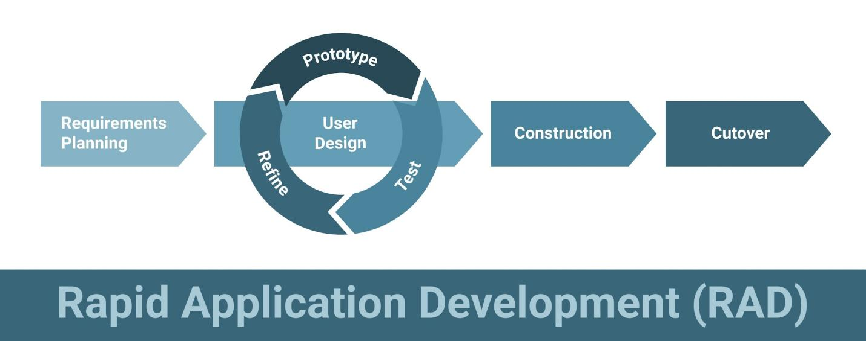
Figure 3.1: Rapid Application Development (RAD) Model.

According to Kendall and Kendall (2019), RAD is an object-oriented approach to systems development that prioritises rapid prototyping and iterative delivery over rigid, linear planning. This methodology is particularly suitable for this project because the development of a visual GIS interface requires continuous user feedback and interface refinement, which the traditional Waterfall model does not easily accommodate.
The RAD methodology for this project is executed in four sequential phases:
- Requirements Planning Phase: This phase involved defining the scope of the system and identifying the constraints of the current manual water management process in Ilorin. Key stakeholders (residents and water agency officials) were considered to establish the data requirements for the "WaterPoint" schema.
- User Design Phase: During this phase, the system architecture and database schema were designed. Prototypes of the map interface were conceptualised using the MERN stack technologies (MongoDB, Express, React/Next.js, Node.js) to ensure they met the operational objectives.
- Construction Phase: This is the core coding phase where the database (MongoDB), backend (Node.js), and frontend (Next.js/Leaflet) are integrated to build the functional system. The "Crowdsourcing Module" was iteratively tested to ensure that GPS coordinates were captured accurately.
- Cutover Phase: This involves the final deployment, testing, and transition from the local development environment to the live browser environment.

3.3 System Analysis

3.3.1 Analysis of the Existing System
System analysis is the process of gathering and interpreting facts, diagnosing problems, and using the information to recommend improvements to the system. The current system of managing water resources in the Ilorin Metropolis is predominantly manual. The workflow currently involves:
Manual Inventory: The Kwara State Water Corporation maintains physical files and paper records containing the location and history of boreholes and wells.
Physical Reporting: Residents must physically visit Ward offices or the State Water Corporation to report broken infrastructure, as there is no remote reporting channel.
Ad-hoc Maintenance: Due to the lack of a centralised digital register, maintenance is often reactive rather than proactive, leading to extended periods of water scarcity.

3.3.2 Weaknesses of the Existing System
The manual nature of the current system presents several significant challenges:
Data Redundancy and Inconsistency: Paper records are prone to duplication, physical degradation, and loss.
Lack of Spatial Visualisation: Manual records lack spatial context. It is impossible to visualise clusters of broken water points or analyze coverage gaps using a physical ledger.
Latency in Fault Reporting: The requirement for physical presence to report faults discourages citizens, leading to prolonged downtimes for critical water infrastructure.

3.3.3 Feasibility Study
Before commencing development, a feasibility study was conducted to determine the viability of the proposed solution.
Technical Feasibility: The project utilises the MERN stack. These are open-source, widely supported technologies. The use of Leaflet.js for mapping ensures the system can run on standard web browsers without requiring heavy proprietary software.
Operational Feasibility: The system is designed with a user-friendly interface similar to standard mobile apps. Given the high penetration of smartphones in Ilorin, the operational barrier for the community is low.
Economic Feasibility: The project relies on open-source tools (OpenStreetMap), eliminating the need for expensive licensing fees associated with commercial GIS software like ArcGIS.

3.4 System Design

3.4.1 System Architecture
The system is built on the Three-Tier Architecture, a standard software design pattern that separates the application into three logical layers to ensure modularity and scalability. This architecture ensures that the user interface, data processing, and data storage are managed independently.
- Presentation Layer (Client Side): This layer is developed using Next.js and Leaflet.js. It handles the user interface and map visualisation. It runs in the user's web browser and is responsible for capturing GPS coordinates and displaying water point markers.
- Application Logic Layer (Server Side): This layer is developed using Node.js and Express.js. It serves as the bridge between the frontend and the database. It processes API requests (such as POST /api/report), performs geospatial calculations, and enforces authentication security using JSON Web Tokens (JWT).
- Data Storage Layer (Database): This layer is managed by MongoDB. Unlike traditional relational databases, MongoDB is a NoSQL database that stores data in JSON-like documents. It was specifically chosen for its native support of GeoJSON, which allows for efficient storage and querying of geospatial data (Latitude and Longitude).

3.4.2 Use Case Design
The Use Case diagram describes the functional requirements of the system from the user's perspective. It identifies the "Actors" (users of the system) and their interactions with the system.
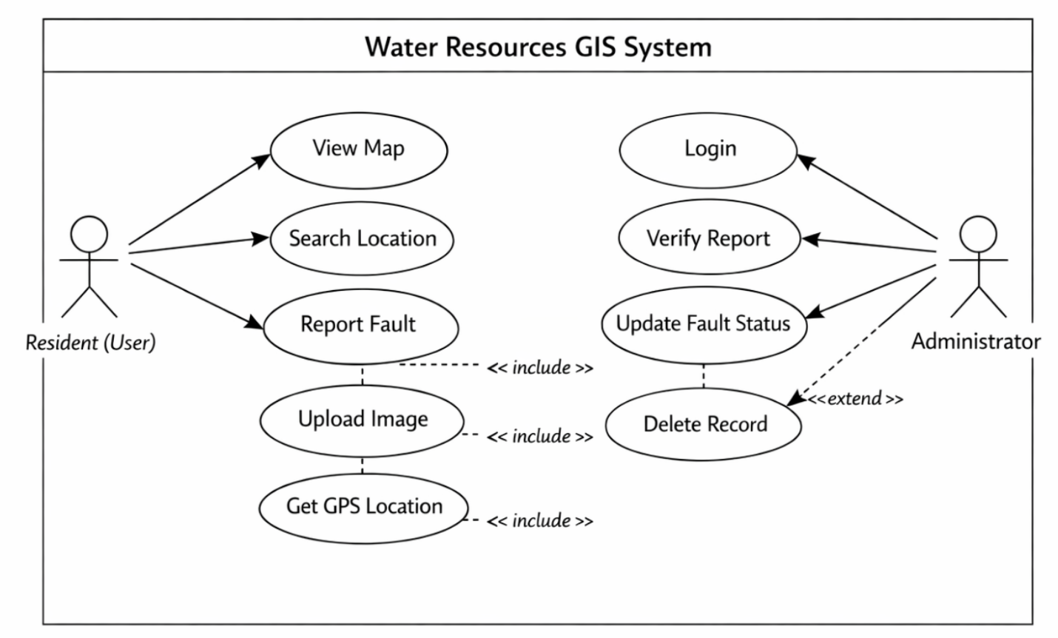
Figure 3.2: Use Case Diagram for the Water Management System.

- Actors:
  - Resident (User): This actor represents the community members. They can View Map, Search Location, Report Fault, and Upload Image.
  - Administrator: This actor represents the water agency or system manager. They can Login, Verify Reports, Update Fault Status (e.g., from 'Broken' to 'Fixed'), and Delete Records.
- Key Relationships:
  - The "Report Fault" use case includes the "Get GPS Location" functionality.
  - The "Update Status" use case extends the "Verify Report" use case, as verification must happen before a status change.

3.4.3 Data Flow Design (DFD)
The Data Flow Diagram (DFD) illustrates the movement of data through the system, from the initial input by the user to the final storage in the database.
- Level 0 DFD (Context Diagram): Shows the entire Geospatial Information System as a single process interacting with two external entities: the Resident (who submits data) and the Administrator (who validates data).
- Level 1 DFD (Decomposition): Breaks down the system into three core subprocesses:
  - Process 1.0 (Data Collection): Input: User submits GPS Coordinates and Photo -> Process: Validation of input -> Output: Validated Data Object.
  - Process 2.0 (Storage): Input: Validated Data -> Process: Database Insertion via Mongoose -> Storage: MongoDB Collection.
  - Process 3.0 (Visualisation): Input: Map Request -> Process: Fetch GeoJSON Data -> Output: Interactive Map Interface on Client Device.

3.4.4 Database Design
The database utilizes a document-oriented structure managed by MongoDB. Unlike relational databases that use rows and columns, this system uses Collections and Documents. This choice is supported by Teke and Tarhan (2021), who argue that NoSQL databases are superior for handling unstructured geospatial data compared to relational SQL databases.
The primary collection for this system is the WaterPoints collection. The schema design ensures that every water point is stored with precise geospatial coordinates (Latitude and Longitude) formatted as GeoJSON objects to enable spatial queries (e.g., finding the nearest borehole).
Table 3.1: Database Schema for 'WaterPoints' Collection
Field Name | Data Type | Description | Constraints
_id | ObjectId | Unique identifier for the record | Primary Key (Auto-generated)
location | GeoJSON Point | Geospatial coordinates | 2dsphere Index (Required for map queries)
type | String | Type of water source | Enum: ['Borehole', 'Well', 'Tap']
status | String | Current condition | Enum: ['Functional', 'Faulty', 'Repaired']
description | String | Details of the fault | Max 500 characters
imageUrl | String | URL of the uploaded photo | Hosted on Cloudinary
dateReported | Date | Timestamp of report | Default: Date.now

3.4.5 Activity Diagram Design
The Activity Diagram models the sequential flow of activities for a specific operation. For this system, the "Fault Reporting Process" is the most critical workflow.
The flow proceeds as follows:
- Start Node: User opens the application.
- Action: User clicks "Report Issue".
- Decision Node: Is the device's Location Service enabled?
  - If Yes: System auto-detects GPS coordinates.
  - If No: System prompts user to manually drop a pin on the map.
- Action: User captures/uploads a photo of the broken facility.
- Action: User submits the form.
- End Node: System displays "Success" message and updates the map marker to 'Pending'.

3.4.6 Sequence Diagram Design
The Sequence Diagram depicts the interaction between objects in a time sequence. It illustrates the technical "handshake" between the Frontend, Backend, and Database.
- Scenario: Submitting a Water Report.
  - User sends a POST /api/report request via the Next.js Client.
  - Express Controller receives the request and validates the JWT (Authentication Token).
  - Express Controller parses the GeoJSON data and saves it to the MongoDB Database.
  - MongoDB returns a Success acknowledgement with the new Report ID.
  - Express Controller sends a 200 OK response to the Client.
  - Next.js Client updates the UI to show the new marker immediately.

3.5 System Requirements

3.5.1 Hardware Requirements (Development & Client)
To effectively develop and deploy the proposed system, the following hardware specifications are required. These specifications ensure the machine can handle the local server (Node.js) and the map rendering (Leaflet.js) simultaneously.
- Processor: Apple Silicon M1 (or equivalent Intel Core i5/i7).
- Memory (RAM): Minimum 8GB (16GB Recommended for running local servers and database tools).
- Storage: Minimum 256GB SSD to accommodate the database and map tiles.
- GPS Module: Integrated GPS in client devices (Smartphones/Laptops) for location tracking.

3.5.2 Software Requirements
- Operating System: macOS (Sonoma/Ventura) or Windows 10/11.
- Development Environment: Visual Studio Code (VS Code).
- Runtime Environment: Node.js (Version 18.x LTS).
- Database Engine: MongoDB (v6.0 or higher) and MongoDB Compass (GUI).
- API Testing Tool: Postman.
- Browser: Google Chrome or Mozilla Firefox (for testing responsive design).

3.6 Conclusion
This chapter has detailed the methodological and technical framework of the research. By adopting the RAD methodology, the project prioritises iterative design and user feedback. The system design, illustrated through Use Case, Data Flow, Activity, and Sequence diagrams, provides a robust blueprint for development. The architectural choice of the MERN stack ensures the system is scalable and capable of handling complex geospatial queries. The next chapter will focus on the System Implementation, Testing, and Evaluation.

REFERENCES
Abdulmumin, Y., & Kana, A. A. (2025). Groundwater potential mapping in semi-arid region of Northern Nigeria by integrating analytic hierarchy process and GIS. Frontiers in Water, 6, 1484753.
Adewuyi, G. K., Adebayo, I. O., & Bello, A. (2025). Geocoding and implementation of a web-based water distribution geospatial information system for Ilorin metropolitan city, Kwara. International Journal of Applied Sciences and Smart Technologies, 5(2), 45–58.
Cinderby, S., de Bruin, A., Mbilinyi, B., Kongo, V., & Barron, J. (2011). Participatory geographic information systems for agricultural water management scenario development: A Tanzanian case study. Physics and Chemistry of the Earth, Parts A/B/C, 36(14-15), 1093–1102.
Davis, F. D. (1989). Perceived usefulness, perceived ease of use, and user acceptance of information technology. MIS Quarterly, 13(3), 319–340.
Kendall, K. E., & Kendall, J. E. (2019). Systems analysis and design (10th ed.). Pearson.
Lins, F. A., Mannich, M., & Dombroski, J. (2023). A Web-GIS for decision making to achieve water quality standards of water bodies through collaborative watershed modeling. Revista Brasileira de Recursos Hídricos, 28, e12.
Olorunfemi, F., Salami, R., & Adeyemi, T. (2025). Geospatial assessment of household water, sanitation and hygiene (WASH) conditions and associated factors in Nigeria. PLOS ONE, 20(3), e023456.
Pressman, R. S., & Maxim, B. R. (2020). Software engineering: A practitioner's approach (9th ed.). McGraw-Hill Education.
See, L. (2019). A review of citizen science and crowdsourcing in applications of pluvial flooding. Frontiers in Earth Science, 7, 44.
Shetty, J., & Dash, D. (2020). Review paper on web frameworks, databases and web stacks. International Journal of Scientific Research in Computer Science, Engineering and Information Technology, 7(4), 1–5.
Sommerville, I. (2016). Software engineering (10th ed.). Pearson.
Space4Water. (2023). Crowdsourcing and citizen science data for water resources management. UN-SPIDER Knowledge Portal.
Teke, I., & Tarhan, C. (2021). Comprehensive study of MERN stack: Architecture, popularity and future scope. International Journal of Scientific Research in Computer Science Engineering and Information Technology, 7(6), 332-338.
Verplanke, J., McCall, M. J., Uberhuaga, C., Rambaldi, G., & Haklay, M. (2016). A shared perspective on participation and GIS. The Cartographic Journal, 53(4), 255–271.
Whitten, J. L., & Bentley, L. D. (2007). Systems analysis and design methods (7th ed.). McGraw-Hill/Irwin.

